Flow Measurement in Gas Drainage
Tim Harvey¹, Ian Gray²
ABSTRACT
This paper reviews the need for flow monitoring in gas drainage and the flowmeters that are available to do this. As suitable flowmeters that are capable of dealing with gas, water and particulate matter do not exist work has been done to adapt ball valves for this purpose. They have been found to fill the function admirably and with a combined manometer and pressure sensor can provide flow ranges in excess of 100:1. They can also be left wide open to avoid blockage when not being used for measurement.
INTRODUCTION
Flow measurement in a gas drainage operation in a coal mine is necessary for the determination of the gas content of an area using a material budget calculation as shown in Equation 1.
Gas in Place = Gas Initially in Place – Gas Drained + Gas Sources (1)
Here
- Gas Initially in Place is the coal’s gas content x density x coal volume in the area being considered
- Gas drained is the gas that is drained out of the area being considered and should include that drained from boreholes as well as that lost into the ventilation system.
- Gas Sources is gas recharge (usually from roof or floor) or could be unmeasured losses from the area being considered.
Borehole flow measurement is usually the most important measurement in determining the Gas Drained term. Its measurement is generally infrequent and poorly done. The determination of gas lost in ventilation should be determined by monitoring airflow in roadways and sampling for gas content changes in the airstream at ends of the roadway.
The Gas Sources term may be significant and should not be ignored. They are the the reason why material balance calculations may be significantly in error. They must be determined by checks on gas content during drainage. These may be point checks by drilling and sampling or, more effectively, by the installation of permanent pressure sensing points, which may be continuously monitored. The latter may be installed from underground (Gray 1987) or from surface in the form of piezometers (Gray & Neels, 2015). The relationship between gas pressure and gas content should however be determined by Native Isotherms (Gray, Wood, Shelukina and Zhao 2015) rather than theoretical combinations of individual gas isotherms as the latter are frequently inaccurate.
The determination of whether a hole is flowing or not and whether it is flowing at half the rate of adjacent holes may be important indicators as to whether it is blocked or not.
Measuring gas flow in an underground environment is difficult and most flow meters are unsuitable for this purpose. This paper presents a simple adaptation of ball valves which enables them to be used for flow metering.
Senior Engineer, Sigra Pty Ltd. Email: tim@sigra.com.au: +61 7 3216 6344
Principal Engineer, Sigra Pty Ltd.. Email: ian@sigra.com.au: +61 7 3216 6344
REQUIREMENTS OF FLOW METERS
Gas flow meters work best if they have a clean, dry gas that flows evenly.
In reality the gas coming from underground boreholes is generally water saturated, contains droplets of salty water and periodically includes ejection of some particulate matter. Gas flow may be interspersed with slugs of water flow. The particulate matter can consist of lumps of coal that may be of 20 mm size being ejected at 20 m/s in some high flow holes.
The obvious way to deal with this would be to place a water separator on each hole and to meter gas flow downstream of the separator. This, however, poses a significant cost, complexity and space constraint on the underground operation. In addition the separator would need to be protected from particulate matter becoming jammed in its entry or exit. This could be achieved by the use of stone traps. The use of stone traps before individual hole gas-water separators and flowmeters is not accepted practice. Separators that are large and therefore have large inlets and outlets can accommodate particulate matter. These are usually placed downstream of any individual hole monitoring. Having a single separator at a gas drainage stub reduces complexity but still poses a significant maintenance problem that is often not properly handled by the mine.
Without protection from water and particulate matter any flowmeter that includes a permanent restriction to full bore flow will partially or fully clog and either give inaccurate readings or block flow.
The use of electronics in coal mines poses significant complications because of the need to meet intrinsically safe requirements. This eliminates most commercial flowmeters, even if they have one of the international IS certifications, because of specific state by state requirements within Australia.
The nature of gas drainage does not however require continuous on line monitoring. Typical requirements would be monitoring daily for the first few days and while drilling continues in the gas drainage stub. This would then be spread out to weekly for the next four weeks and then monthly. This means a gas drainage hole typically only needs about 30 flow measurements during its entire operational life.
An underground flow meter needs to be:
- Reliable and accurate to +/-5%;
- Able to measure over a wide range of flow rate;
- Able to monitor flow streams containing gas, water, solids;
- Cope with Intermittent gas flow with slugs of water;
- Not have any permanent partial blockage to flow
CURRENT PRACTISE
The current usage of flow meters varies depending on whether the installation is underground or on the surface.
Underground
In underground gas drainage of mines, the current flow measurement practice varies but may include:
- installing flow measuring devices on every drainage hole;
- measuring total flow from drill stub;
- measuring flow on surface at the top of gas risers;
- no measurement at all; and
- combination of any of the above.
The frequency of measurement varies and includes continuously, weekly or fortnightly, when the staff remember and when staff have the time to carry it out.
The most commonly used flow meter in underground gas drainage is the differential pressure orifice meter with a removable orifice plate. These orifice plates cannot be left in the pipework so a measurement means opening a Victaulic joint, inserting the orifice plate, closing the joint and then taking a pressure and differential pressure measurement. Following this the orifice plate needs to be extracted by the reverse procedure. This is time consuming and leads to leakage from or into the gas pipelines. Venturi meters have also been used.
The flow environment, with coal particles as well as gas means that anything that restricts flow is likely to lead to a blockage. Line pressure and differential pressure are at times measured with an approved electronic instrument, a U-tube manometer or Magnehelic gauges. The latter generally succumb in a few days to the wet and corrosive gas that are encountered in gas drainage operations.
Other meter types and instrumentation may be used but the short duration, IS and communications issues means they are generally impractical for underground gas drainage installations.

Surface
Traditionally surface gas drainage installations have used venturi meters, orifice plates and other differential pressure devices. Any one of these that have upstream facing ports such as pitot tubes, and Annubar meters suffer from blockage. Some installations have used turbine flowmeters. More recently ultrasonic flow meters are becoming more popular as prices have reduced. These have both a reasonably wide measurement range and potentially higher accuracy. They also have the advantages of being non-intrusive, with no moving or wearing parts and retain their calibration settings.
FLOW METER TYPES
This section describes the various types of flow meters. Some of the information in this section is drawn directly from Crabtree 2009.
- Differential pressure meters
Differential pressure flow meters encompass a wide variety of meter types that include: orifice plates, venturi tubes, nozzles, wedge, venturi-cone, Annubar, pitot tube, elbow and variable area devices. Differential pressure meters are the most widely used technology for flow measurement. With the exception of the pitot tube which measures the difference between the stagnation pressure and the static pressure of a thin probe, or simply monitoring a pressure drop over a long length of pipe, all other differential pressure devices involve placing some restriction to flow in the pipework.

The flowrate is determined from a combination of the continuity and Bernoulli’s equations. The general equation describing pressure drop across a differential pressure device such as an orifice plate is given in Equation 2 (Streeter, Wylie and Bedford, 1998).

$Q=CA_{o}\sqrt{\frac{2∆p}{ρ}}$ (2)

Where $C$ is a coefficient depending on the geometry and Reynolds number of the flow
$A_{o}$ is the area through the flow orifice
$∆p$ is the pressure drop across the device
$Q$ is the flow rate at the density of the fluid
$ρ$ is the density of the fluid
The nature of Equation 2 means that the pressure drop rises with the square of the flow rate. This limits the flow range to about 4:1 with a single differential pressure measurement sensor. Ranges may be extended by using high and low range differential pressure sensors. Two of these may extend the range to 8:1.

The Sigra ball valve flow meter is a differential flow device with the important difference that the flow restriction is temporary and the flow area is variable.

- Mechanical meters
There are two types of mechanical meters these are positive displacement and turbine meters.
- Positive displacement meters have several different types including
  - sliding vane
  - oval gear meters
  - lobed impellers
  - oscillating pistons
  - nutating disc
  - fluted rotor meters
  - wet-type gas meters.
These are highly accurate and are generally used for custody transfer applications of clean fluids. Because of their mechanical nature they are subject to wear and have relatively high pressure losses. Their use is limited to low volume applications and they are not suitable for high or low viscosity fluids.
- Turbine meters are used in both for both gas and liquid flow. They have a high range-ability that gives them a measurement ratio of up to 20:1. They can operate at very high pressures and are available to suit a wide range of pipe sizes. Turbine meters have have high accuracy (+/- 0.5%) and excellent repeatability. They can be suitable for very low flows. At higher flows, cavitation can be an issue. They are subject to pressure losses of up to 30 kPa at maximums flows and bearing and impeller wear needs to be monitored. Propeller, and impeller meters also fall in this class.

All these devices place a restriction in the flow path and can be easily damaged by particles.

- Oscillatory Flow Meters (Vortex meters)
Oscillatory flow measurement systems involve three primary metering principles: vortex,
vortex swirl (a commercial device) and the Coanda effect. In all three, the primary device generates an oscillatory motion of the fluid whose frequency is detected by a secondary measuring device
to produce an output signal that is proportional to fluid velocity.
Vortex meters use the presence of a bluff body within the conduit to generate vortices that are shed behind it. The frequency of shedding is proportional to the flow rate and their calibration does not change with time. The limits are determined at the low-end by viscosity effects and at the upper end by cavitation or compressibility. Vortex shedding flowmeters are highly linear but need to operate at high flow rates with Reynolds numbers greater than 30 000. They are not suitable for low gas pressures. The flow range for gases is about 20:1.
The presence of a bluff body within the flow stream means that vortex shedding devices may cause jams of particulate matter in dirty gas streams.
- Electro-Magnetic Flow meters
Electro-magnetic flow meters are only suitable for ionic liquids and not gases. Apart from this major limitation in gas drainage applications they are admirable devices with which to measure liquid flow.

- Ultrasonic flow meters
Ultrasonic flowmeters are suitable for both liquids and gases. They are a non-intrusive measuring device which can be used on a wide range of pipe sizes from 75 to 3000mm with accuracies of around 1% and have range-ability up to 125:1 for higher quality meters. The three basic principles used in ultrasonic metering are the Doppler method, the time-of-flight method and the frequency difference method.

Apart from not obstructing the flow, ultrasonic flowmeters are not affected by corrosion, erosion or viscosity. Most ultrasonic flowmeters can be bi-directional.

Advantages
- Suitable for large diameter pipes,
- No obstructions, no pressure loss,
- No moving parts, long operating life,
- Fast response,
- Weld-on transducers may be installed on existing pipe-lines,
- Multi-beam systems can be used to eliminate the effects of flow profile, and
- Not affected by fluid properties.

Disadvantages
- In single-beam meters the accuracy is dependent on flow profile,
- Fluid must be acoustically transparent,
- Expensive, and
- The pipeline must be full – not a problem with gases.

Application limitations

For the transit time meter, the ultrasonic signal is required to traverse across the flow, therefore the liquid must be relatively free of solids and air bubbles. Anything media with a density different to the process fluid will affect the ultrasonic signal.

- Coriolis meter
Coriolis meters are used for high accuracy mass flow measurement. Apart from custody transfer applications they are used for chemical processes and expensive fluid handling.

Advantages
Some of the many benefits include:
- direct, in-line and accurate mass flow measurement of both liquids and gases,
- accuracies as high as 0.1% for liquids and 0.5% for gases,
- mass flow measurement ranges cover from less than 5 g/m to more than 350 tons/hr,
- measurement independent of temperature, pressure, viscosity, conductivity and density of the medium,
- direct, in-line and accurate density measurement of both liquids and gases,
- mass flow, density and temperature can be accessed from the one sensor, and
- can be used for almost any application irrespective of the density of the process.

Drawbacks

- expensive,
- many models are affected by vibration,
- current technology limits the upper pipeline diameter to 150 mm, and
- secondary containment is sometimes necessary in case of pipe failure.

- Thermal Gas Flow Meters
These devices involve electrically heating an element within the flow stream and measuring the temperature of it or around it. These flowmeters are highly accurate for use with clean gasses and can operate with flow ranges up to 150:1. The need for a clean gas means that they ae unsuitable for gas drainage flow measurement.

The characteristics of various flowmeters is summarised in Table 1.

Requirements for Differential Pressure Measurement
To accurately calculate the gas flow in a differential pressure flow meter requires:
- Absolute pressure measurement
- Differential pressure measurement across the flow obstruction
- An obstruction of known form and properties
- Pipe diameter
- Gas temperature
- Gas properties – density, viscosity, cp/cv
The accuracy of absolute pressure measurement needs to the nearest kPa and the differential pressure measurement needs to be as accurate as possible, as does the measurements of diameters and areas. Figure 1 gives a comparison of the accuracy of some of instruments used for differential pressure measurements.
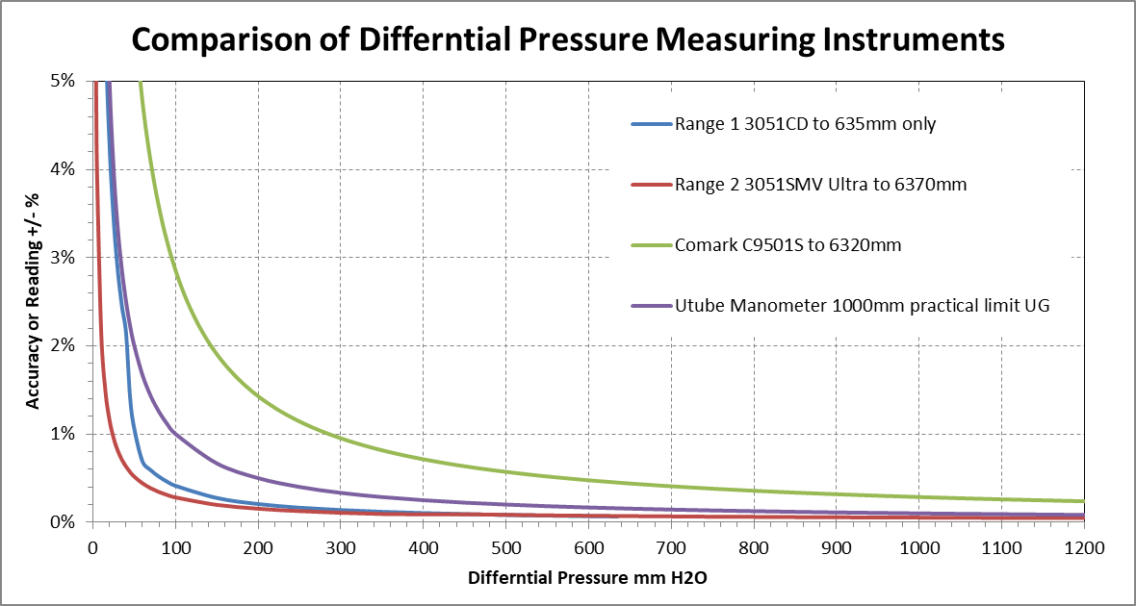
Figure 1. Comparison of differential pressure measuring instruments
Note: The 3051CD is a Rosemount differential Pressure Transducer, 3051SMC Ultra is a Rosemount MultiVariable transmitter, the Comark C9501S is an IS portable pressure Instrument and the data for the U tube manometer assumes that this instrument can be read to 1 mm of water head.

Flow meter type | Dirt blockage | Flow range | Accuracy % | Cost | IS required ** | Fluid type | Comment
Differential Pressure
Orifice Plate (per plate) | X * | 4:1 | 2 | Low if not instrumented | If instrumented | Clean fluids only | Moderate loss
Orifice plate ( multiple) | X * | <100:1 | 2 | Low if not instrumented | If instrumented |  | Moderate loss
Sigra ball valve flow meter | ✓ | >100:1 | 2 | Low | No | Non viscous fluids | Moderate loss
Venturi | ✓ | 4:1 | 0.75 | Low if not instrumented | If instrumented | Non viscous fluids | Low loss
Wedge meter | OK | 5:1 | 2 | Low if not instrumented | If instrumented | Non viscous fluids | Medium loss
V-Cone | OK | 10:1 | 0.5 | Medium | Yes | Non viscous fluids | Medium Loss
Pitot tube or Annubar | X | 3:1 | 1 | Low if not instrumented | If instrumented | clean Fluids | Low Loss
Variable area | X | 10:1 | 1 | Low | No | All fluids | Low flows only
Other devices
Ultrasonic | X | up 125:1 | 0.2 | High for large | Yes | Clean fluids | No Loss
Vortex shedding | X | 30:1 gases | 1 | Medium | Yes | All fluids (cleanish) | Low loss
Turbine | X | 20:1 | 0.2 | Medium | If instrumented | Clean fluids only | Low loss
Positive displacement | X | up to 100:1 | 0.5 | Wide range | If instrumented | Clean liquids or gas | High loss
Magnetic | some | >30:1 | 0.2 | Low | Yes | Liquids only | No loss
Coriolis meters | ✓ | <=100:1 | 0.5 | High | Yes | All fluids | To 150 mm diameter
Thermal mass flow | X | up to 150:1 | 0.2 | Medium | Yes | Gas | low loss

Table 1. Summary of flow meter types.
*Blockage is likely to occur if the orifice is left in place.
** IS refers to the need for intrinsically safe electronics
SIGRA FLOWMETER DEVELOPMENT
The problem of gas flow measurement underground is not trivial and requires a quite specialised solution. In the author’s view the commonly adopted practise of opening Victaulic couplings to enable the temporary insertion of an orifice plate for flow measurement is completely unsatisfactory both from time and safety viewpoints.
What is needed is a low cost precision flowmeter with a wide flow range that poses no obstruction to flow when not in use. The low cost aspect of this means minimal or no machining or fabrication while the high flow range means doing something different from a standard differential pressure device with a maximum to minimum flow ratio of 4:1.
Several ball valves have been tested as flow meters and been found to be suitable. They can be left fully open when not being used for flow metering. When being used to measure flow they can be partially closed to form an adjustable area orifice. In addition they may be used as a shut in valve on the standpipe or in the conduit from the standpipe if the borehole needs to be closed in.
The ball valves have been calibrated using air against a range of standard orifice plates using water filled manometers to determine the difference in upstream line pressure from atmospheric and the pressure difference across the orifice plate. The air pressure and humidity was determined from an adjacent weather station and the line air temperature was directly measured. The testing was accomplished while drawing air through the flow meters and then in discharging from the blowers into the meters. In the latter case the temperature and inlet pressure were significantly different.
The calibration constant derived for each angle of opening of each valve was the term CAo in Equation 2. The value of C is a complex function of the inlet pipe size to valve area ratio open (dependent on opening angle) and the Reynolds number of the inlet flow. The latter is not however a critical factor in the flow calculation.
The calibration for one type of ball valve flowmeter is shown in Figure 2. The value of CAo is made dimensionless by dividing by the pipe cross sectional area. The exact values for this curve are dependent on the ball valve design.
A photograph of a ball valve fitted with a protractor by which to measure the valve opening is shown in Figure 3.
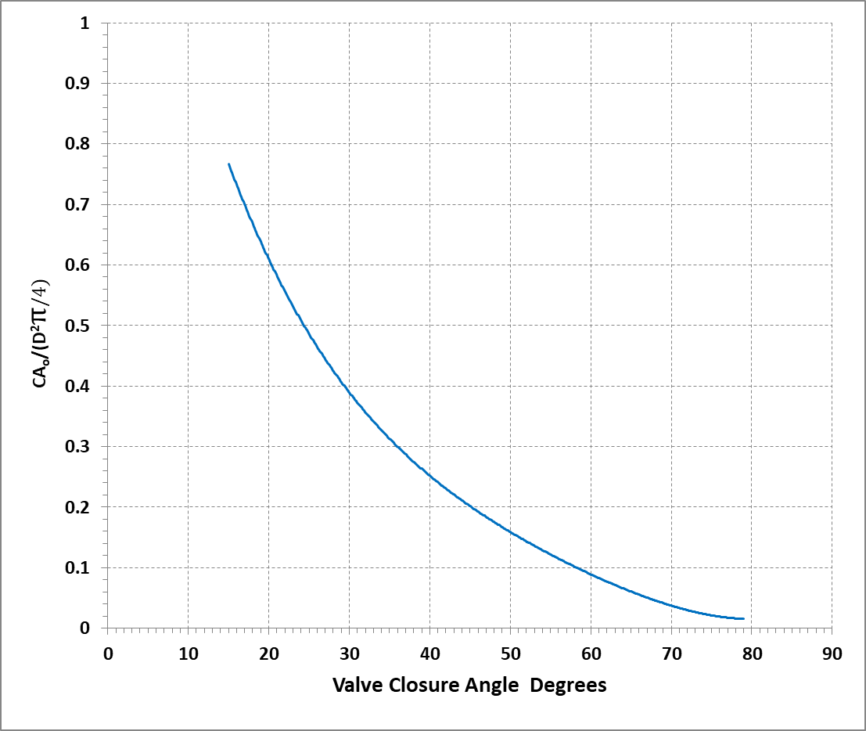
Figure 2. Value of CAo/Pipe Area for a ball valve.
A water filled manometer is difficult to transport, fill and read underground. Therefore an alternative simple device has been constructed to measure the gauge flowing line pressure and the differential pressure. It is not electronic and therefore avoids intrinsic safety issues. We have named it a Bubbleometer. A drawing of it and the Ball Valve Flowmeter is shown in Figure 4. It comprises a water filled cylinder in which are installed two tubes and a slide valve.
Using the Bubbleometer requires connecting it to the Ball Valve Flowmeter with the tapping valves closed. The slide valve is then moved to connect the 50 mm tube to the upstream tapping while the cylinder is connected to the downstream pressure. The valve is then gradually closed until bubbles just begin to be emitted from the base of the clear 50 mm tube. This is easily seen as the meniscus is gradually pushed down the tube. If the flow is high and the angle of closure is too low to be reliable the slide valve can be moved to the 500 mm tube and the ball valve closed further so as to just produce a bubble. The use of bubbles enables the differential pressure to be measured to 0.5 mm water gauge accuracy.
The gauge pressure may then be determined by moving the slide valve to connect the 500 mm tube to atmospheric pressure and then moving it to connect the upstream tapping. The compression or expansion of the gas within the tube may be measured on the scale within the cylinder and can then be used to calculate the gauge pressure.

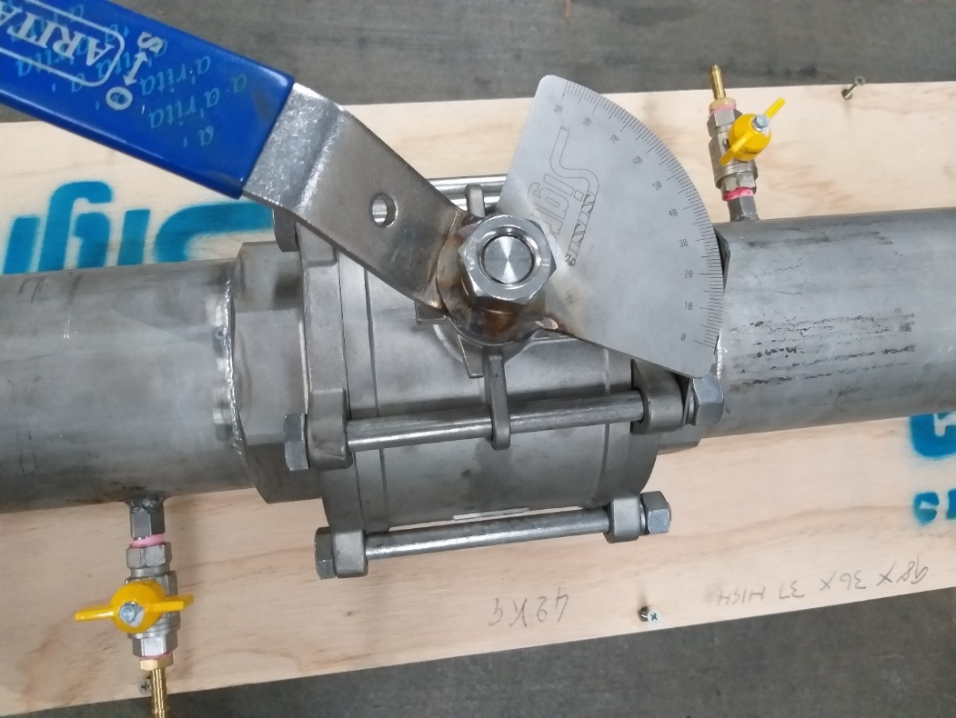
Figure 3. Ball Valve Flowmeter with tappings and fitted with protractor to measure opening angle.

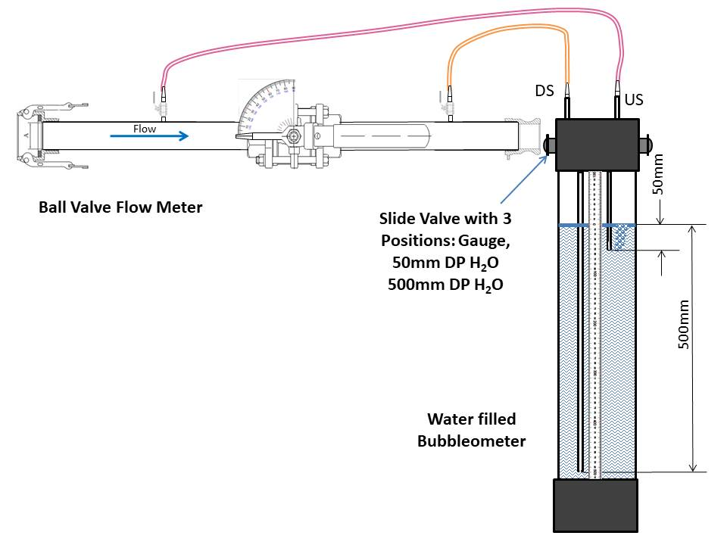
Figure 4. Ball Valve Flowmeter and Bubbleometer.
The determination of the flow rate requires knowledge of
- The local atmospheric pressure
- The gas composition - taken from a bag sample
- The gas temperature – measured very occasionally at the borehole collar and normally equal to seam and seam water temperature
- The gauge pressure - determined from the reading of gauge pressure in the Bubbleometer
- The Bubbleometer tube used (50 or 500 mm immersion)
- The valve angle
Using an assumption of 100 % humidity the STP gas flow may be readily calculated.

USE OF THE BALL VALVE FLOWMETER AND BUBBLEOMETER
The method of use envisaged for the flowmeter is that the valve on each standpipe should be replaced by a Ball Valve Flowmeter which then becomes the shut off valve for the borehole. If the drainage hole forms part of a gas drainage stub then a Bubbleometer should be hung in each gas drainage stub and connected to each flowmeter in turn to obtain the requisite measurements for flow determination.
Flow measurement in this underground situation will always be compromised in the initial stages of gas production by slugs of water. There is nothing that can be done except to wait until these have passed when taking a measurement. Other lesser fluctuations in flow may be able to be damped by fitting dead volumes (tubes) and flow restricting nozzles to the connections between the Ball Valve Flowmeter and the Bubbleometer. This has not yet been tested.
It should be noted that ball valves should not be permanently left in the partially closed position because of wear on the ball and the seals.

CONCLUSIONS
The need for gas flow measurement in gas drainage is presented in this paper. It forms an important part of material budget calculation of gas in place. It also enables such elementary problems as borehole blockage to be detected.
Because of the unique conditions of gas flow measurement underground a simple high range (100:1) flowmeter has been developed from a ball valve for this purpose. This has the advantage that it can be used as a shut off valve on the borehole. Because only about 30 measurements are required in the life of a gas drainage hole to be able to measure the gas it produces a flowmeter that does not operate most of the time is required. The ball valve is a precision machined device which can remain open most of the time thus avoiding problems with wear and blockage. The Ball Valve Flowmeter may be used with a variety of electronic pressure and differential pressure measurement devices. However the method suggested here is to use a non-electronic device which enables the precise measurement of gauge and differential pressure. This has been named the Bubblometer.
The Ball Valve Flowmeter can be readily obtained in 25, 50, 80 and 100 nominal bore sizes. It may be used in other applications which require the periodic measurement of dirty gas flows.

REFERENCES

Crabtree, M A 2009. Industrial Flow Measurement. Master’s Thesis, University of Huddersfield.
Gray, I 1987. ‘Reservoir Engineering in Coal Seams, Part 2: Observations of Gas Movement in Coal Seams’. Society of Petroleum Engineers, Reservoir Engineering, February 1987. SPE Paper No.14479. www.onepetro.org

Gray, I, and Neels, B 2015. ‘The Measurement of Gas and Liquid Pressure in Rock and Soil.’ in
Proceedings of the Ninth International Symposium on Field Measurements in Geomechanics. 9-11 September 2015, Sydney.

Gray,I, Wood, J, Shelukhina, I and Zhao, X 2015.’Isotherms, gas contents and diffusion coefficients of coals and shales’. In Proceedings of SPE Asia Pacific Unconventional Resources Conference and Exhibition. Brisbane, Australia, 9–11 November 2015. – SPE177006. https://www.onepetro.org/conference-paper/SPE-177006-MS

Streeter, L Wylie, E B and Bedford, K W 1998. Fluid Mechanics, Ninth Edition. McGraw-Hill. ISBN 0-07-062537-9.

