Sigra in Dam and Hydro Engineering

# Introduction

Dams are usually designed for long service lives which frequently have to be extended, as the complications of removing a dam and replacing it are huge. Extending a dam’s service life probably means a complete re-appraisal of the structure, its foundations and the spillways and tunnels that carry water. This means measurement of the dam’s current state and possibly works to improve its safety. Frequently there is a need to raise the dam height to increase the capacity of the reservoir or to overcome the effects of silt build up. As the consequence of dam failure is generally totally intolerable, designs need to be conservative and works that are constructed need to be monitored carefully so that any deviation from design behaviour may be detected and its consequences evaluated.

Dams are large structures that are supported by the ground in all its forms of rock and soil. It is this interface between the natural ground and the man-made structure that provides some of the greatest engineering challenges. The ground is just as much a part of the dam as a concrete arch wall, and a part that generally has far less well defined parameters. It is what is inherited from the earth when a decision is made to build a dam at a particular location. The dam builder cannot specify the particular material properties of the ground; ~~it~~ must gain an understanding of what the properties are and design and build a structure that is compatible with these. Modification of the natural ground behaviour is always complex and frequently an expensive process.

# Dam Site Location

The location of a dam is principally determined by need and topography. Is there a need for water storage or electricity generation and does the topography permit storage? In addition, there needs to be an adequate water supply to fill it.

The next most important question is whether it is possible to build a dam and what form the dam will take. The geology is just as important as geometry of the valley in which a dam is to be constructed. These days virtually any study of a new dam location will begin with satellite imagery. This can provide detailed information on geometry, an indication of the surficial material and lineaments that indicate the presence of faulting. It can also be used to detect surface movement with some precision. This is of particular relevance to determining whether active landslide movements exist in any steep areas surrounding the proposed reservoir. The use of Interferometric Synthetic Aperture Radar (**InSAR**) is particularly useful in detecting such movement.

Regional seismicity is important. Consideration must be given to what seismic events have occurred prior to construction and what events may be triggered by the construction of the dam and the filling of the reservoir behind it. This may affect the dam structure or may trigger landslides.

## Site Investigation

The detailed site investigation normally begins with geological mapping of the surface features. It is frequently backed by geophysical investigations using seismic and resistivity surveys. In some rock types, induced polarisation surveys may also be useful. Geophysical surveys will only ever give a blurred image of what exists below the surface and it is then necessary to probe in detail using drilling.

Drilling only provides geological and geotechnical information on what is intersected by the borehole. By using the core obtained and borehole geophysics, it is possible to link individual hole information to the geophysical surveys conducted from surface to obtain a holistic picture of the dam site.

Most drilling for dam investigations is by coring, and for any holes longer than about 40 m, wireline coring is far more efficient than conventional coring. The type of wireline coring is important as it must provide core samples that can be tested for their properties in a laboratory (Sigra, 2020). It also needs to provide a hole diameter that is suitable for field testing. The Boart Longyear HQ-3 triple tube wireline coring system has been found to be ideal in this respect. It provides a core size of 60.9 mm diameter and a hole diameter of 96 mm. The HRQ drill string frequently used with HQ-3 coring is recommended for use to borehole depths of 2500 m, which is of great value in deep hydroelectric projects.

While cored boreholes are of great use, when they get to be too long they become slow to drill, even with the use of a wireline core retrieval system. This is where open hole drilling and borehole geophysics can be used to great advantage. Directional open holes may be drilled at great speed for the purpose of assessing tunnel alignments. In suitable formations drilling speeds may exceed 500 m/day. To make use of these drilling methods, the hole should be surveyed using borehole geophysics. Where complex geology needs further clarification, it is possible to drill a branch off the main hole and collect a core sample as shown in Figure 1. Frequently the limitation on such drilling is the hydraulic pressure that may be developed in the borehole without causing the rock to hydrofracture.

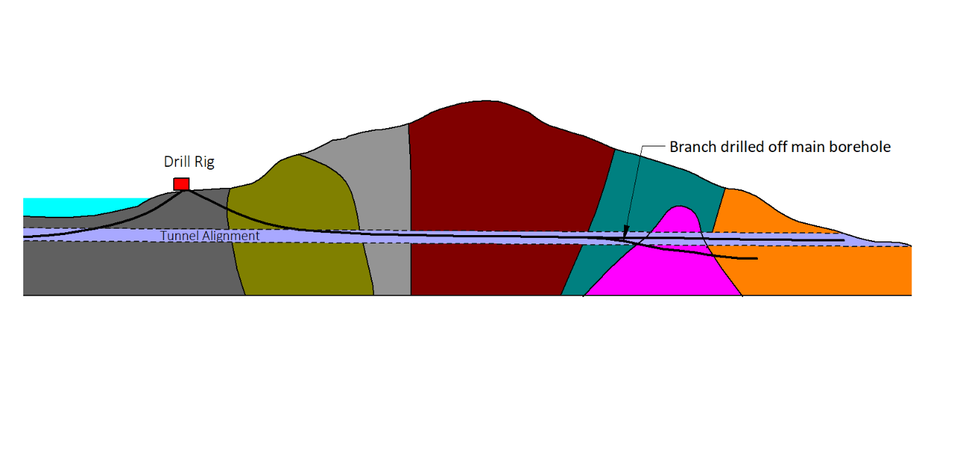

Figure . Directional drilling along tunnel alignment and drilling an additional branch to gather additional geotechnical and geological information

### Hydraulic Testing of the Ground

The nature of hydraulic testing undertaken needs to focus on what needs to be measured. The normal parameters that govern fluid flow through porous media need to be considered. These are the hydraulic conductivity and the storage behaviour of the ground. The latter are referred to as storativity and specific yield, depending on whether the situation is one of a confined or unconfined groundwater case. This terminology is generally applied to laterally extensive aquifers and may be very applicable to the ground under the reservoir. In this case the leakage from one layer to the next can be extremely important, and testing to determine this behaviour should be undertaken.

Frequently however dams need to be constructed in areas which contain many joints that pass through multiple lithologies. Determining how fluid will flow through these becomes more complex.

All testing of the hydraulic flow characteristics of rock masses should be accomplished in situ, rather than in the laboratory, so as to incorporate the effects of jointing and other discontinuities. The basis of this testing is inducing fluid to flow by creating a hydraulic head (pressure) difference, from which a flow rate and pressure response is measured. The only sensible analysis of this hydraulic testing is by examination of the transient pressure behaviour. Despite its continued use in civil engineering, steady state analysis of field testing does not provide credible results. The principal reason for this is the need to separate the general behaviour of the rock mass from that around the test well bore, which may be modified by drilling fluid, stress concentrations or local fracturing. To overcome these problems, tests which involve production or injection followed by a shut in period without flow are the most useful. The drill stem test of the oil and gas industry exemplifies this. An example of Sigra’s drill stem testing equipment is shown in Figure 2.

A single borehole test can only provide information on the average hydraulic conductivity (permeability) and the fluid pressure at the test zone. If assumptions are made as to the storage characteristics of the rock mass it is then possible to calculate near well bore loss terms and, more importantly, the radius of investigation of any test. Single borehole tests may also be used to establish the presence of boundaries to a permeable rock mass being tested, if these exist. This is accomplished by the examination of the transient response and any net pressure change in the test zone before and after production or injection.

To determine anything more about the rock mass requires additional observation points and therefore additional instrumentation. This is achieved primarily by pressure measurement through the use of piezometers which are separated at a known distance from the site of fluid production or injection. With the benefit of additional pressure monitoring points, it is possible to determine the storage behaviour of the rock mass. It is also possible to determine anisotropy. However, separating anisotropy from inhomogeneity requires the use of multiple test holes and piezometers. Sequential pulse testing is particularly useful for this purpose. This involves undertaking hydraulic testing in a single hole test. Piezometer(s) are then installed in the first hole and a second hole is drilled and tested so that the transient response may be determined both in the second test hole and the piezometers in the first hole. This second hole is then fitted with piezometers and a third hole is drilled and tested. This approach may be repeated and is extremely effective in determining changing conditions of ground fluid behaviour.

The method chosen for installing pressure sensors (piezometers) is extremely important. This is usually because multiple piezometers are required in a single hole and because the information they provide must be correct. The traditional sand fill, bentonite pellet and cement grout installations are extremely time consuming, and seldom can more than two suchpiezometers be fitted into a single borehole.

Sigra provides three options for the installation of piezometers. The first option is Sigra’s proprietary cement displacement system, which allows the use of multiple, permanently installed, piezometers in a single hole. Sigra also uses both inflatable packers and swell packer systems to isolate specific rock joints and install temporary and permanent monitoring equipment. All these systems are testable both at and after installation, a feature that is essential for any instrumentation.

A broader article on groundwater test techniques and piezometer installations may be found in Gray (2017). This also includes a description of Sigra’s drill stem test system to be used in conjunction with HQ core drilling operations and more information on pulse testing.

The stability of slopes surrounding a reservoir are frequently important. As groundwater frequently controls the stability of these, it becomes essential to monitor the slopes over time, prior to construction, so as to assess fluid pressure fluctuations within these. In some cases this requires a large number of piezometers to be installed in the slope. Such installations may require moderate frequency monitoring (once a minute) in high intensity rainfall events and much slower monitoring (daily) in other times. Sigra manufactures data acquisition systems for such a purpose.

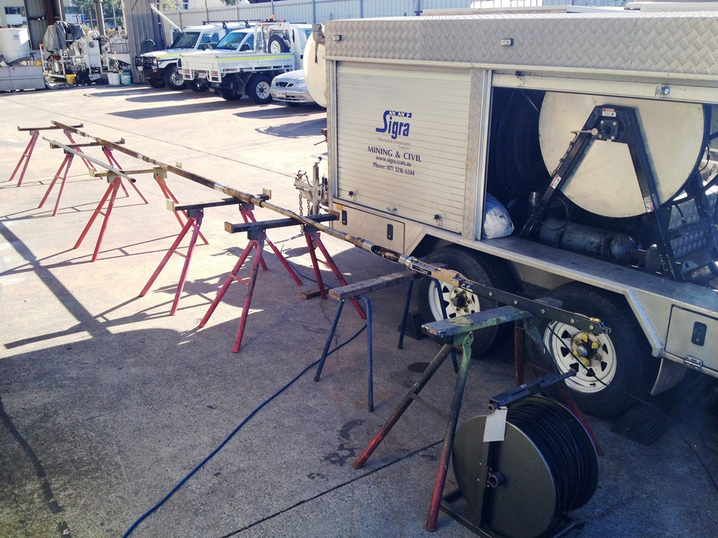

Figure . Sigra’s Drill Stem Testing tool and trailer

### Ground Stress

The stress in soils is important in the context of whether clays are under or over consolidated and the state of the soil with respect to critical state soil mechanics. The determination of soil stress is usually derived from dilatometer or pressure meter tests and is interpreted in terms of empirically derived relationships. Most soil stresses only separate the vertical and the horizontal components. This generally does not cause too many problems because of the limited depth of soils of engineering interest and the stress limits in soils which lie between the active and passive states.

In the case of rock, the stresses may also be limited by friction along faults. However, because intact rock has cohesive as well as frictional behaviour, the stresses may be much higher.

Determining whether rock stress is low is just as important as determining whether it is high. Normally a high stress is of concern because it may lead to rock breakage. However, a low stress can be of equal concern as it fails to supply the stress to mobilise friction across joints. A low rock stress may also be insufficient to constrain fluid within a tunnel which would then require lining, possibly with steel if tensile stress would be developed in the unlined tunnel wall.

In the case of water saturated rock, the action of fluid pressure within the rock mass is important in how it changes the effective stress. This may be through poroelastic behaviour or through the direct action of pressure within open joints.

Because stress is a tensor with six components it takes some effort to measure it. Indeed, in some cases it is impossible to derive the full stress tensor. In many cases it is more important to measure the variability of stress over a large number of lower accuracy measurements than it is to get a small number of precise measurements. The fundamental reason for this is the variability of stress within the rock mass. The more complex the geology then usually the more complex the stress regime.

The measurement of rock stress falls into two categories. These are the measurement of rock stress in elastic rock and that in inelastic rock. The case of elastic rock refers to rock that has not failed and will not fail during the test process but does not necessarily have to be linearly elastic. Inelastic rock either has failed or will fail during the test process and contains fractures. It also includes rock that behaves in a plastic manner.

If the rock behaves elastically the most logical means of stress measurement is by overcoring, where the deformation or strain is measured by coring over some device called a cell within a borehole. The analysis of overcore systems is straightforward for isotropic linear elastic rocks. It is more complex when the rock is non-linear and anisotropic. The challenge is in measuring the rock properties correctly in the laboratory and applying these properties to derive the stress from the deformation measured in the field.

If the rock contains joints at too close a spacing to use overcoring then a stress measurement technique that may be used is hydrojacking. This involves sealing a test zone within a borehole on each side of a joint with packers. Fluid is then pumped into the test zone, pressurising it until the fracture opens as can be seen by an increase in the flow rate. The pumping is then stopped and the fracture closes. The closure pressure is determined from the pressure decline characteristic and corresponds to the stress acting normal to the joint. If there are well spaced joints at different orientations then each of these can be tested to give components of the stress tensor. Practically this is seldom the case, as either there are multiple joints close together or there are a limited range of joint orientations. In the case of multiple joint sets, it is extremely difficult to either isolate a single joint or to know which joint has been opened, and all that can be obtained is a measurement of minimum stress.

For pressurised tunnels in rock, tunnel designers can use the hydrojacking method to obtain a direct measurement of fracture opening pressures.

If a borehole suffers from breakout, then it is an indication that problems will exist in rock engineering. Breakout can take the form of lines of compressive failure in the borehole wall or tensile cracking in cases where there is a great difference in the major and minor stress perpendicular to the hole. It is not possible to determine the stresses orthogonal to a borehole from breakout width information alone. Additional information is required, which must include the strength of the rock and another stress measurement. The petroleum industry normally uses hydrofracturing to arrive at a minimum stress and correlations between sonic velocity and strength to provide the additional information. This approach can only provide an approximate solution though.

Stress measurement by hydrofracturing involves sealing a section (test zone) of a borehole with packers and pressurising the test zone until the rock fractures. Pumping is then halted and the fluid leaks into the rock mass. As the pressures reduces in the test zone, the fracture will eventually close. The fracture closure pressure may be detected by the nature of the pressure decline curve and can yield the minimum stress state. Determining the state of major stress requires re-opening the fracture after closure and assuming the axis of the borehole is perpendicular to the plane of major stress, the rock behaves in a perfectly linearly elastic manner and the fracture closes perfectly after initial opening. In addition to these complications there is frequently the practical problem with the packers initiating borehole wall fracturing, and also being able to supply adequate pressure to fracture strong rocks at depth.

An indication of the difference between the major and minor stress perpendicular to a borehole may be determined from measuring the ovality of the core. This requires the use of a drill bit that does not re-grind the core after it is initially cut. This is a low cost test that can provide near continuous sampling of the stress changes from the core.

### Rock Property Determination

Many sedimentary and metamorphic rocks are frequently anisotropic. Therefore, the test processes used to assess their properties need to reflect this. Where jointing exists, it is likely to have a major effect on rock behaviour and such jointing needs to be measured. This is best performed as part of the core logging process. Core logging enables the lithology to be determined and the joints to be measured in terms of orientation and the nature of the joint. The joints can then be aligned with information from the acoustic televiewer scan of the hole. Proper core logging also enables visual observation for inhomogeneity and the choice of samples, and how they should be geotechnically tested.

All too frequently, testing has become a rote process of taking representative samples of each lithology and sending them off for uniaxial compressive testing, interspersed with the occasional triaxial test, to determine failure properties. The problem with this approach is that the failure mode in these tests is by shearing at an acute angle to the sample axis which may be across the bedding planes. Furthermore, the only pre-failure parameters measured are the axial Young’s modulus and associated Poisson’s ratio. As most laminated rocks have quite different mechanical properties depending on the direction, this is very limiting. Not only are most laminated sedimentary rocks anisotropic but they frequently display quite significant non-linearity prior to failure. The test process, therefore, needs to be thought about carefully.

Gray (2020) reviews existing test methods for determining rock properties. These tests can be subdivided into tests for elastic and plastic behaviour prior to peak strength being reached, and for the strength at failure.

#### Index Tests

Index tests for strength are valuable, though they do not give any fundamental parameter. Point load testing is a particularly useful index test because it can be performed on fresh core on site before any expansive clays have time to react. Care must be taken to perform point load tests as soon as possible after core extraction. Core must be kept moist to prevent changes in strength due to desiccation.

In the point load test the core is loaded to failure both axially and across the diameter. The resulting value is normalised to a 50 mm diameter core. The point load test gives a difference in strength of the rock to loading in different directions. The index is just that though, because the test imposes a complex loading situation on the core, comprising local compression and the generation of tensile stress through the shape of the point and the core. The test may also be biased by the selection of unrepresentative stronger material for testing.

Another useful index test is the Protodyakanov Index in which lumps of rock or coal are struck with a drop hammer in a cylinder to make them break up. The test gives a useful first pass at rock toughness and correlates reasonably well with tensile strength. The Protodyakanov test is predominantly used in Russia and China.

The Brazilian test in which a core is loaded by a line load across opposite diameters is also really an Index test as it generates tensile stress by the shape of the core and the line load imposed on opposing sides. The analysis of this test is dependent on the core being perfectly linearly elastic, something that is unlikely in sedimentary rocks. Brazilian tests cause a complex failure in the rock involving tensile and shear failure.

Because of the importance of the bedding planes on the failure of laminated rocks, test processes that account for these need to be adopted. A modified form of the GOST (ГOCT, 1988, государственный стандарт – Russian governmental standard) shear test is particularly suitable for this. It is a simple shear test in which the ratio of normal stress to shear stress can be varied by changing the angle of loading in a universal test machine with respect to the failure plane. In the modified form used by the authors, the shear plane is perpendicular to the core axis enabling shear parameters (cohesion and friction angle) to be determined along the bedding plane. This measurement is useful in determining the shear strength of dam foundations.

Tensile strength is also important. The tensile strength across bedding planes may determine how a foundation buckles or how the roof of a tunnel fails.

Figure 3 shows the Mohr’s circles of failure for the various strength tests along with the Mohr–Coulomb failure envelope. The simple shear test in this figure refers to a test purely to measure cohesion of the rock perpendicular to the core. This is measured with respect to a different failure envelope than that shown in Figure 3. The GOST test shear is shown as a point, though it could equally well be shown with a Mohr’s circle passing through it.



Figure . Stress loadings imposed by various rock tests. Gray, 2020

The rock mass will strain prior to failure at some combination of stress level. Some of this strain is elastic and some of it may be plastic. What is elastic may not be either isotropic or linear. In this respect, the usual use of uniaxial compressive testing is totally inadequate for determining the full elastic properties, though cyclic uniaxial testing can be used to reveal any plastic offset. The development of triaxial testing to determine the full pre-failure behaviour of the rock is extremely important. In the form used by Sigra, the rock is described in terms of linear orthogonal behaviour for any state of stress. These tangential values of rock property are converted to secant behaviour for real analysis.

There is little value to be obtained from numerically modelling rock behaviour using linear elastic models with unrealistic failure behaviour. The pre-failure behaviour of the rock mass is just as important as the strength at failure. Whether the rock mass reaches a state of stress where it will fail depends on its initial behaviour and stress.

The behaviour of rock under the influence of water may be tested by examining its slaking behaviour. In its simple form, this test involves putting crumbs of rock in water and observing whether they disassociate. In cases of doubt, the mineralogy should be determined using scanning electron microscopy. The presence of reactive clays, such as smectite, can lead to problems of rock deterioration on exposure. This may affect any excavation in rock.

There is another rock property that may be very important and should be measured. This is its poroelasticity. The effective stress within any rock or coal mass that contains fluid at pressure will depend on its poroelasticity. It is particularly important in porous rock or cleated coals and can be measured as part of Sigra’s triaxial test process.

### Borehole Geophysics

Borehole geophysics gives some indication of lithology types and more particularly, changes in lithology.

From a geotechnical viewpoint sonic logs and acoustic televiewer images are particularly useful. Full waveform sonic logs can be interpreted in terms of the dynamic Young’s modulus and Poisson’s ratio. The interpretation is, however, invariably given in terms of isotropic rock behaviour and therefore information on anisotropy cannot be obtained. The use of correlations between the Young’s modulus determined from the sonic log and laboratory determined moduli can be useful. Attempting to assess rock strength from the sonic log is tenuous.

The use of oilfield tools with rotating dipoles would permit the determination of fast and slow shear waves and with them an indication of anisotropy.

The use of the acoustic televiewer is immensely valuable in determining structural features and bedding plane orientation from the borehole image. It does not remove the need to log core to see the structural features and examine their physical state. However, by reconciliation of the core log and that of the acoustic televiewer image, it is possible to orientate the core, and thus save on the complications of obtaining orientated core by other more complex means. The acoustic televiewer image also enables the borehole wall to be examined for breakout or tensile fracturing. These features are a function of stress at the borehole wall caused by concentration of the rock stress by the borehole. In dry holes where acoustic televiewers cannot be used, optical televiewers may be used.

Hatherly et al (2009) take the use of borehole geophysics even further with the development of the Geophysical Strength Rating. Borehole geophysics alone cannot, however, make up for having some core visually inspected and physically tested. The properties of sedimentary rocks are too complex to determine from geophysics alone. The process should be one of using the geophysics to assist in the interpolation of properties from point measurements.

# Design

## Considerations For The Choice of Dam Type

The type of dam that will be constructed will depend principally on the height of water it is required to impound, the ground it is built on and on the materials that are available to build it. The options include arch dams and gravity dams built of concrete, earth or rock. Each of these has its benefits for use in certain situations.

Some, such as concrete arch dams require rigid foundations and abutments and cannot tolerate movement in these. Others must be built to accommodate the deflection of the ground below.

Where there are significant cuttings or natural gorges involved, consideration must always be given to the movement of the rock mass into these. While this movement may lead to rockslides or landsides, the process is not one of normal gravitationally based slope failure, but rather the relief of confining stress and the resulting movement. Rocks may typically contain up to 1000 microstrain of compression and this may be released by excavation over large distances, sometimes kilometres. Even 500 microstrain being released over 200 m equates to a movement of 0.1 m. This movement may not take place until water levels have risen in the dam leading to a reduction in effective normal stress across a bedding plane thus releasing frictional restraint. The consequences of this are the movement of a dam abutments. Accommodating two dam abutment movements of 0.1 m requires a suitable design.

## Detailed Design

The detailed design of the dam should follow the site investigation. However, as the design progresses it may be desirable to return to site and drill additional boreholes. This is always a difficult decision, as the choice lies between leaving the unknown to be dealt with during construction or by improving the level of certainty prior to construction. The answer to this depends on the consequence of the level of uncertainty. If the unknown regards the safety of the design, may lead to a fundamental change in design or may cause a significant change in the project cost, then the answer is to go back and investigate further, no matter the extent of the delay.

# Construction

The process of dam construction follows the steps of the diversion of the river, preparing the foundations and building the dam. It can then be allowed to fill. It can also involve tunnels to take water from the dam.

## Managing Open Joints and Faults – An Alternative Approach

One of the problems that may be found in dams and tunnels constructed in rock is the potential for water loss from a dam or water ingress into a tunnel through open joints .The question is how to deal with these joints? This depends on the nature of the joints and how they will change with construction and dam filling.

One of the traditional methods is to cement grout these joints to seal them. This is often undertaken by drilling multiple holes and cementing section by section. In some cases this is quite appropriate but in others it is not. The complication is always whether the grout will be washed away before it has either penetrated far enough into the joints to be effective or before the grout has set. Balancing setting time and viscosity of the grout is a challenge.

Take for example a deep tailrace tunnel in a hydroelectric development which was being excavated through a fault system in granite. Here drilling encountered extremely high water flows with pressures that exceeded 8 MPa. The tunnel advance was halted while the water inflow was brought under control by drilling multiple small holes and grouting in each of these in sequence. Achieving this was no small task as it involved the dangerous process of manually pushing an inflatable packer into the holes against the water flow and pressure, which took time to build up after packer sealing then grouting. This process was repeated many times.

The better approach would have been to drill an exploration hole through a properly cemented well head located some distance away from the faults. The use of a well head and managed pressure drilling equipment would prevent uncontrolled formation water outflow. Once the fault zone had been delineated then a possibly better option would have been to get an oilfield high pressure, high volume hydrofracture pump system to deliver cement grout into the hole. This would have the effect of displacing water, widening the fractures and filling any voids with cement. It would also have been a far safer and quicker operation to conduct. Such equipment is readily available in many parts of the world.

# Monitoring

There is a need to monitor what is happening throughout the construction and operational phases. Monitoring is essentially comprised of three parameters – deformation, pressure and stress. In the case of dams and tunnels it may also include the measurement of flow. Outlined below are a range of monitoring technologies used to monitor structures on or in the ground.

## Deformation Monitoring

For structures with high construction costs and potential social impacts, deformation monitoring is vital during and after construction of a dam. This may be conducted to confirm the expected design settlement is not exceeded during construction, or to monitor the deformation of the dam structure during initial filling of the reservoir.

### InSAR

On a large scale, deformation monitoring using Interferometric Synthetic Aperture Radar (InSAR) is particularly useful. It can remotely detect millimetres of surface movement. While this may not assist on the dam construction site itself, it is of immense value in detecting movement around the construction works.

### Lidar

It is possible to determine the shape of virtually anything by the use of Light Detection and Ranging. This is a remote sensing method that uses light in the form of a pulsed laser to measure distance. It can be used from static sites or from drones. For precision, measurements must be related to some fixed survey stations. The use of comparative multiple Lidar surveys can detect the movement of excavations or slopes.

### Surveying

Following the remote sensing options for deformation comes the use of traditional survey instruments. These have been significantly advanced by the availability of automatic theodolites which can survey multiple reflectors in sequence and transmit the information from these.

### Strain Monitoring

Strain monitoring involves the measurement of length change between fixed points. This can be achieved by surveying but can also be undertaken at a much smaller scale by the use of strain gauges. In civil engineering it is common to use vibrating wire strain gauges to monitor the length change of a 150 mm long element. Such elements can be readily incorporated into reinforced concrete. While the vibrating wire gauge is old fashioned, it is reliable by the fact that it transforms an analogue measurement into a digital (frequency) signal that may be transmitted over distances of 1 km. It is of course possible to use more conventional resistance gauges with suitable electronics. The key to the success of these is converting the resistance change to a digital signal as close to the measuring device as is possible.

Another more recent development is that of strain measurement through fibre optic cables. This may be achieved at discrete locations along a fibre optic cable using Fibre Bragg Gratings or along the length of the fibre optic cable using either Brillouin Optical Time Domain Reflectometry (BOTDR) or Rayleigh Scattering. The number of Fibre Bragg Gratings in a fibre optic cable is limited. The BOTDR can be used over several kilometres with an accuracy of approximately 15 $με$ (microstrain) while the Rayleigh scattering systems can deliver 1 $με$ resolution with a location accuracy of 20 mm over up to 70 m length (Webb et al, 2017).

The problem with any form of cable, whether fibre optic or copper, is that if it breaks the system stops functioning.

### Inclinometers

Inclinometers have been used in ground engineering works for decades. In the traditional form they consist of a probe that is lowered inside a borehole casing and takes measurements of the inclination of the hole. The casing is typically grooved so that the tool may be oriented and the tool itself may obtain a uniaxial or biaxial measurement. By recording the changing inclination profile with depth, it is possible to integrate this information to obtain changes in position with depth from the original survey. This system is effective but is labour intensive if multiple readings are to be taken during and following construction.

A more recent alternative has been the use of micro-electro-mechanical (MEMS) accelerometers connected into electronically integrated strings which are semi-permanently located in inclinometer casing. These transmit information from which their individual inclinations may be determined. Such systems hugely reduce the labour required to obtain measurements. They are however limited in accuracy by the fixed spacing between the sensors. Traditional manually operated inclinometers could produce as close a measurement along the casing as the operator had time to take. Both systems are also limited by the accuracy of the sensors they contain.

In addition to the above system the option for optical monitoring exists. New developments by Sigra promise accuracies of the order of 0.2 mm lateral displacement over 60 m lengths.

All inclinometer boreholes are limited by local major displacement that shears the hole and casing.

### Extensometers

Extensometers are useful devices in monitoring the change in length along the length of a borehole. To be useful they need to be multi-point devices so that relative movements may be determined. Devices that are installed in open holes are less than ideal in hydraulic structures because they leave open a pathway for leakage. Sigra has its own systems of extensometers that may be cement grouted into boreholes with up to 24 monitoring points in an HQ cored borehole (96 mm diameter).

### Time Domain Reflectometry

Where the potential for significant movement exists in the ground along surfaces such as joints, it is important to find out where that movement occurs. In this respect time domain reflectometry is useful. If a cable is cement grouted into a borehole and the hole either suffers tensile or shear deformation the cable is broken. Time domain reflectometry may be used to find where the break point is in the cable.

### Tiltmeters

Depending on the range of the instrument, tiltmeters may be incorporated into dam construction and can monitor changing tilts of fractions of an arc second. They are one of the tools of deformation measurement that do not require a reference point. The reference is orientation of the earth’s gravitational field.

## Pressure Monitoring

The monitoring of fluid pressure in the ground is a key measurement in dam construction and the determination of the state of health of the dam and the surrounding ground. Fluid pressure affects uplift forces on the base of the dam and is a component of effective stress in the rock or soil.

Piezometric measurement can take many forms. Traditionally holes were drilled in the ground and pipe with a filter tip was placed in the hole. Sand was placed around the filter tip and then bentonite followed by a cement grout. It was essentially impossible to install more than two such filter tips in a hole. Monitoring was originally conducted by dipping the tube with an instrument to measure the water surface depth. With the advent of suitable pressure transducers and electronics, a pressure transducer could be left in the hole to record the water pressure. This approach had the advantage that the pressure transducer could be removed for calibration or maintenance. It was also possible to pump water into the tube and be sure that it had some connection to the ground. This sort of system still has a delayed response to fluctuations in water pressure because of the storage volume within the pipe. The response is greatly improved by sealing behind the pressure sensor with an inflatable packer.

With the availability of reliable pressure transducers, the approach of placing multiple pressure transducers into the borehole and cementing the entire borehole with a cement-bentonite mixture became popular. The assumption behind this was that the permeability of the cement bentonite mixture would enable hydraulic connection over the short distance to the borehole wall and fluid in the rock mass behind it. The assumption also made was that the distance between pressure monitoring points in the borehole would enable isolation between pressure sensors. The flaw in this was that the cement bentonite mixture frequently blocked connection with the fluid in the rock mass and hydraulic interconnection along the borehole dominated, so that the pressures measured by transducers in the monitoring hole frequently just showed hydrostatic pressure with no way of checking whether this was correct or not. Another complication associated with the use of this installation method was the very slow response of the pressure transducers to fluctuations in fluid pressure within the rock mass.

To overcome this, Sigra developed its cement displacement system incorporated into its piezometer installations. In this, the pressure transducers are deployed on a grout pipe into the borehole. Each sensor is connected to the borehole via a filter tip. Also connected to the filter tip is a pressure relief valve and a tube to surface. After the piezometer string is lowered into the hole the filter tips are flushed. The hole is cemented either in full or in stages as controlled by the needs to avoid hydrofracture of the rock mass by the cement. The filter tips are again flushed with a small quantity of water and the cement grout is permitted to set. After this has taken place more water can be pumped through the filter tips and the pressure rise and decay associated with this can be monitored. This pressure decay provides proof that there is a fluid connection between the piezometer and the formation to be monitored. A lack of pressure change on the other piezometers during this test proves there is zonal isolation between the piezometers at different depths. The cement grout that is used is highly impermeable to avoid leakage within the borehole. It is still dependent on the stability of the pressure transducers used because they cannot be replaced

Another variant of the system is to cement grout a series of tubes into the borehole and to connect their filter tips to the porosity of the rock mass by the cement displacement process. Transducers may then be installed in each of the tubes and fixed in place by the use of packers. This enables the removal of transducers for maintenance purposes.

Sigra can also supply multi stage packer systems to isolate sections of an open borehole or for use inside a casing that is cemented into a borehole. The casing must be either perforated using a perforating gun or fitted with filter zones that may be cleared by cement displacement. The packers used within this system may be inflatable, if it is required to remove them for maintenance, or permanently located by the use of swell packers that expand when submerged in water. In between the packers, pressure transducers are used to monitor fluid pressure and convey this to surface via a data cable.

## Stress Change Monitoring

It is not possible to measure stress and monitor its change subsequently with the same instrument. The normal process is to conduct stress measurement by overcoring and then to install within the borehole a stress change cell. All stress change devices involve strain or deformation measurement. This strain or deformation is converted to a stress change by knowing the stiffness of the cell and the rock mass. Most of these stress change cells are overcore devices and are soft, meaning that they have negligible stiffness compared to the rock they are designed to monitor. This causes problems with borehole wall stability under stress as they do not support the wall of the hole to which they are attached. Glue in devices can work to monitor limited duration stress change events because of creep.

Stress change monitoring is best undertaken with a cell that has a similar stiffness to the rock mass and is pre-stressed to something approximating the stress in the rock. Sigra achieves this by cement grouting stress change cells into the borehole using a grout that is stiff and expands after initial set to pre-stress the hole wall and the cell. These cells can be either of a vibrating wire type or use resistance strain gauges.

## Monitoring Old Dams

When it is possible to gain access to most of the surface of existing dams, examinations may be made. Ground probing radar, sonic or resistivity testing may then be undertaken. Obtaining information from within the dam requires a hole to be drilled. Drilling a hole requires care so that it does not contribute to the weakening of the dam structure. This means not drilling through critical steel reinforcement nor inducing piping into the hole. Measurements may then be taken and monitoring instruments placed in the hole. Any holes should then be cement grouted to avoid hydraulic problems or potential weakening of the structure in the future.

# Case Studies

## Case 1 – A Hydroelectric Scheme Investigation

Sigra was employed to investigate the subsurface conditions for a deep hydroelectric power station. This work involved 80 stress measurements conducted in meta-sediments and igneous rock. These were conducted using Sigra’s IST2D overcore system and by hydrojacking of highly jointed shallower rock. The deeper measurements were at depths of more than 1000 m and were focused on the turbine hall, the electrical switchgear hall, the headrace and tailrace tunnels. The stress measurements showed that above a certain level the stresses increased with depth but below this the stresses became almost random, changing hugely in magnitude and direction as shown in Figure 4 and Figure 5. To gain an understanding of the reasons for this stress variation, a detailed study of the acoustic televiewer images of the boreholes was undertaken. This revealed sudden changes in the dip and dip direction of the bedding planes within the metasediments as shown in Figure 6. These were consistent with two and possibly three major faults. Further examination of the stresses showed that they were relieved by most of the fault planes and concentrated around the fault tips. The consequence of this work was that the location of the major underground works was moved.

The hydrojacking of the fractured rock mass also revealed that the stresses within the upper fractured rock mass were inadequate to confine head race tunnel pressures. This led to a re-design of these.

Sigra also conducted drill stem testing in boreholes to define the hydraulic behaviour of the rock mass. This replaced the packer test process normally used in such civil engineering works.

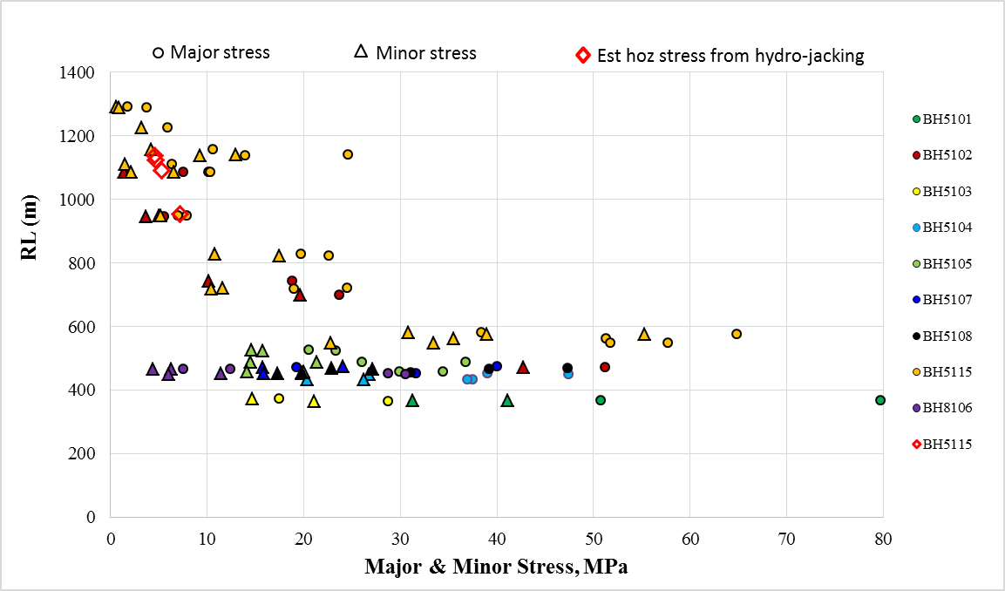

Figure 4. Major and minor principal stress versus RL in western area

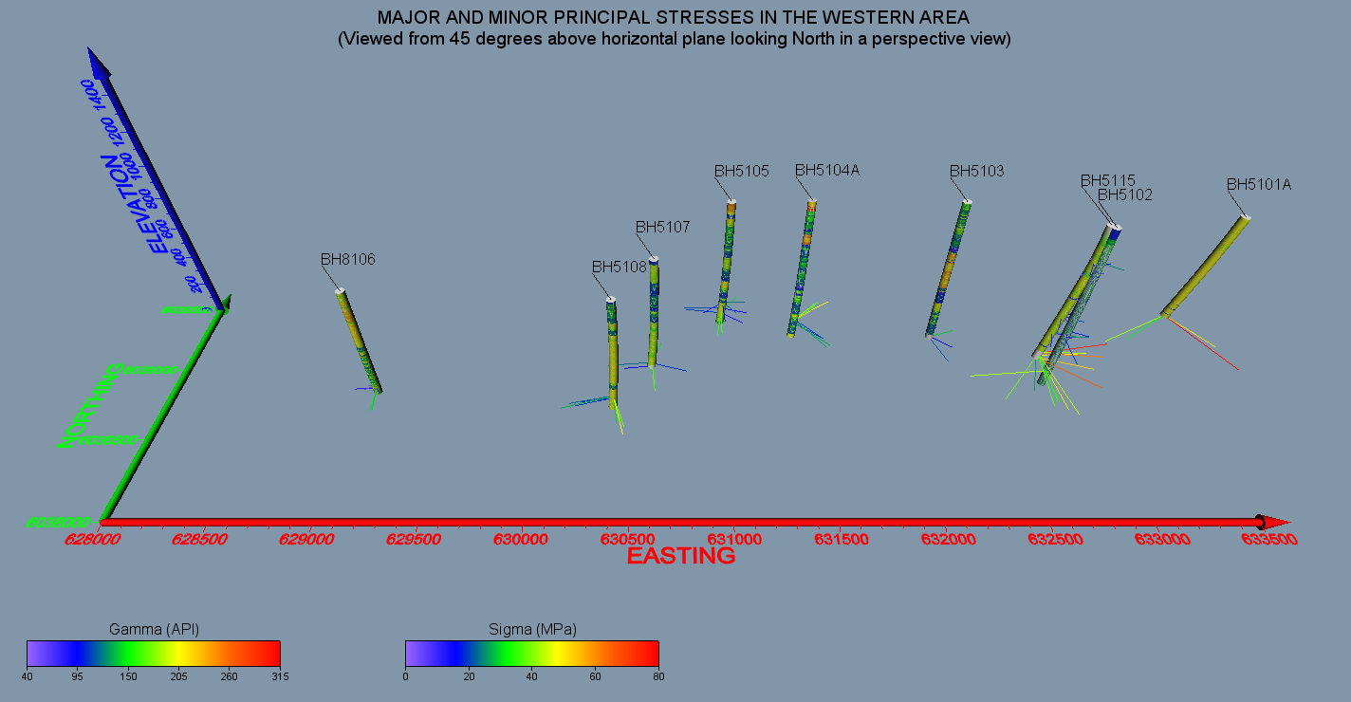

Figure . Major and minor principal stresses in the western area.

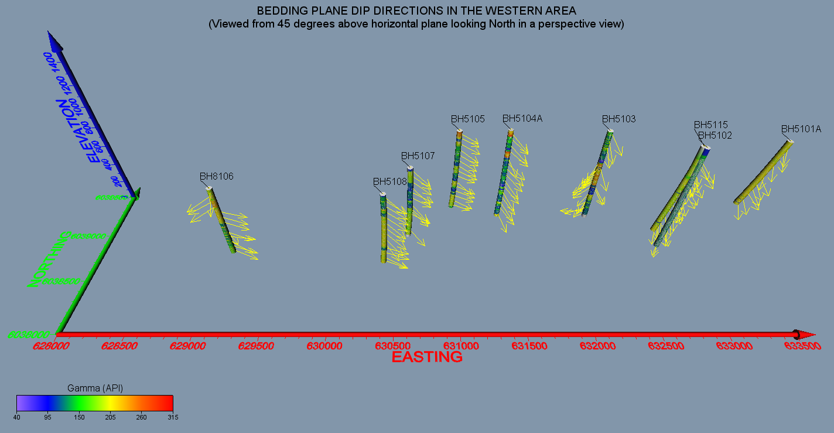

Figure . Bedding plane dip directions in the western area

## Case 2 – The Bogong Hydroelectric Project

Sigra was asked to measure the stresses in a 5 m diameter headrace tunnel in granodiorite for this hydroelectric project in Victoria, Australia. The tunnel was well advanced and being developed with a hard rock tunnel boring machine. The problem was that a fault had been detected ahead of the tunnel alignment and the question was raised as to whether water pressure in the tunnel could lead to re-activation of the fault. Sigra was asked to measure the Insitu stress and provide an answer.

At the time, the only drill rig on site had broken down and some means was required to measure the stress. Given the round nature of the tunnel it was decided conduct a novel overcoring operation. At each of four locations the tunnel surface was smoothed with a diamond disc grinder. Strain gauge rosettes were then adhered to the rock surface and allowed to set along with thermistors to measure the rock temperature. Following the setting of the glue and stabilisation of temperature each of these strain rosettes was surface overcored using a concrete core drill. After each overcore the rock was allowed to return to temperature prior to its final strain measurement and removal from the wall of the tunnel for the measurement of their moduli. The four combined surface stress measurements were used to develop the stress tensor at this location along the tunnel.

In retrospect, and had a drilling rig been available, it would have been useful to drill a hole from the tunnel to intersect the fault some distance from the tunnel and to conduct a hydrojacking operation. This would have provided a more direct measurement of the normal stress to the fault while the overcore measurement would have enabled the shear stress acting on it to be evaluated.

## Case 3 – Mining Under Stored Water

Metropolitan Colliery in the Illawarra region of New South Wales planned to mine under the Woranora Reservoir. The mining method was longwall with narrow faces so that the goaf formation was sub critical and surface subsidence was not induced by mining. However, monitoring of this had to be undertaken. Part of the monitoring involved groundwater pressures. To do this Sigra installed some 80 piezometers in 16 boreholes from 500 to 620 m in depth. Some of these holes contained 10 piezometers. The majority of the piezometer strings were installed using Sigra’s cement displacement system. A few of the pressure transducers have been lost through the mining process but the majority are still in service 12 years after their installation.

The data from these is retrieved using Sigra’s data acquisition systems and transmitted via the cellular phone network to Sigra and then placed in cloud storage.

Figure 7 shows Sigra field engineers installing 9 piezometers into a 600 m deep hole at Metropolitan Colliery.

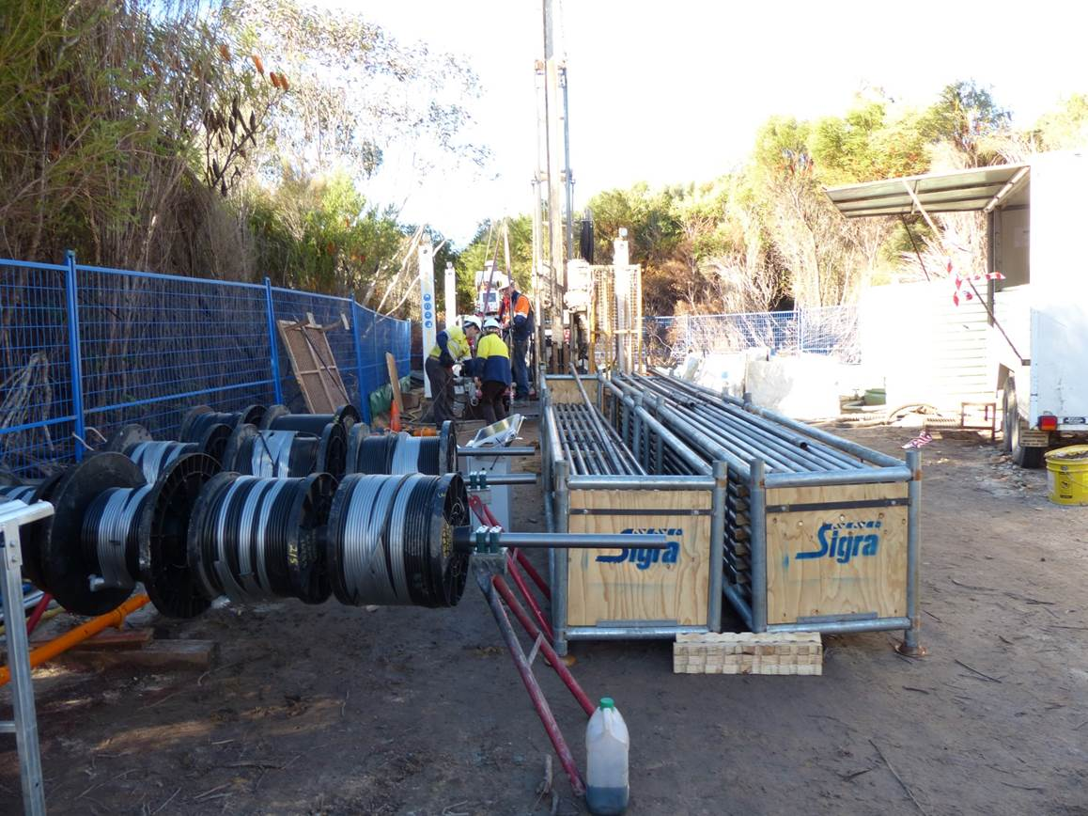

Figure . Sigra Field Engineers installing Piezometers at Metropolitan Colliery

## Case 4 – A Moving Cut Slope – Springfield

The Department of Main Roads and Transport in Queensland asked Sigra to provide an engineering solution to assist with the control of the movement of a large cut slope on a highway as shown in Figure 8. The cut slope was moving at 1 mm per day in dry weather and accelerated to 3 mm per day in wet weather. Sigra focused on dealing with the groundwater aspects of the project. A series of pumping wells and piezometers was set up and pumping tests were undertaken. These showed the complex nature of the groundwater situation where trachyte and basalt overlay claystones. The failure surface was within the claystones. It was found that groundwater could be controlled and with it the rate of movement of the rock mass. A monitoring array was set up using Sigra data acquisition systems which monitored the piezometers. This was used to feed into a real time model of water movement in the slope. It was also used to control pumps.

Later study showed that the driving force behind the movement was the relief of stress within the rock mass caused by the cutting. When ground water levels rose the reduced effective stress on bedding within the claystones enabled the rock above to slide. This was a large scale movement that affected an area of some hundreds of metres dimension.

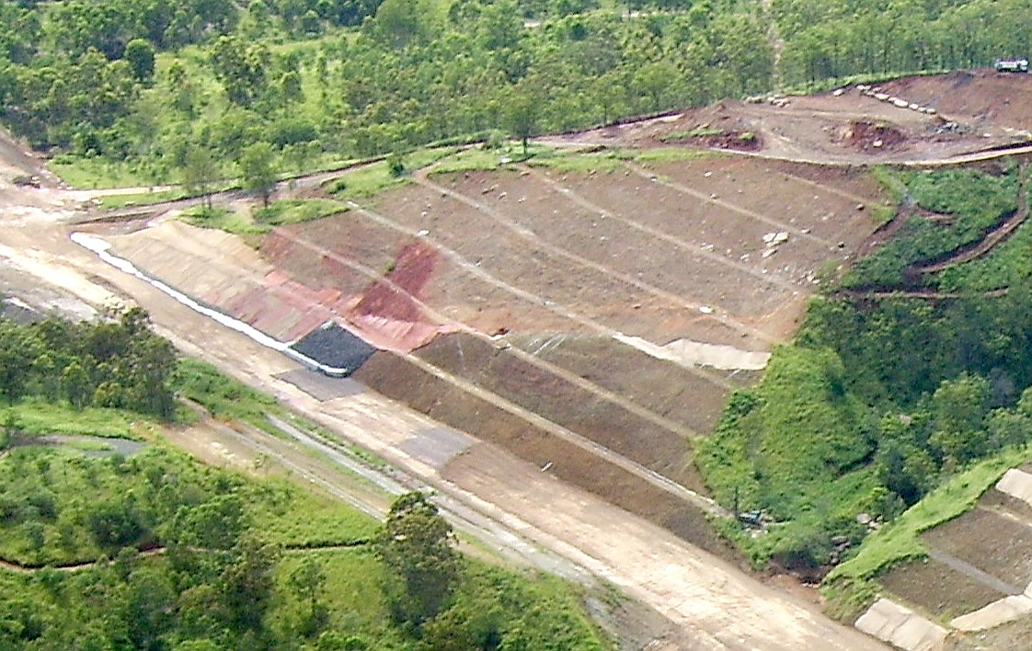

Figure . The moving cut slope at Springfield.

## Case 5 – Mining Under a River

Moranbah North mine in Central Queensland, Australia was mining under the Isaac River. This was for much of the year a dry, but large sandy riverbed. However, in times of torrential rain this could swell to a torrent which was several hundred metres wide. The mine was a longwall coal mining operation where the goaf formed fully with a surface subsidence of some 3 metres. The question asked of Sigra was will this water reach the mine and flood it?

Sigra worked with a drilling contractor to progressively core drill and conduct injection fall-off testing to determine the permeability of the rock in the goaf. This was carried out in three boreholes, one mid longwall panel and two located near the chain pillars. It was found that the strata was highly permeable immediately above the mined out coal seam but that it re-established a relatively impermeable state where the caving resulted in the rock collapsing as slabs that did not lose their alignment and reconnected. The area near the chain pillars of the longwall was a little more permeable higher up than that mid panel.

This testing led to the conclusion that the mine was unlikely to flood. To improve the confidence level surface subsidence cracks were ripped with a bulldozer and filled with dry bentonite powder.

## Case 6 – Drilling from a Tunnel into Sands

The Liang Tang tunnels in the New Territories area of Hong Kong required the construction of cross passages. These were to be developed in saturated, decomposed granite and sands derived from them. The means chosen to stabilise this by the contractor, VSL-Intrafor, was to drill and grout, using tube-a-manchette grouting systems so as to stabilise the periphery of the cross passages. This shifted the problem of cross passage collapse to one of drilling complications. The risk was that an open hole might allow the sand to pipe into the tunnel forming a sink hole on surface resulting in flooding of the tunnel. Alternatively, if the drilling fluid pressure was too high, the sand may have liquefied.

As neither case could be tolerated, Sigra was asked to build a managed pressure drilling system. This permitted the holes to be drilled under controlled back pressure which was above that required to avoid piping and below that which might lead to liquefaction. This equipment was based upon Sigra’s blow-out prevention equipment used in gas exploration boreholes. It was however smaller and used a much lower pressure choke (pressure relief valve) to control the pressure of returning fluid. This is shown in Figure 9.



Figure . Drilling contractors using Sigra’a managed pressure drilling system while drilling cross passage boreholes in the Liang Tang Tunnel

# References

Gray, I (2017). *The Measurement of Permeability and Other Ground Fluid Parameters*, in Drilling for Geology II Conference, pp. 59-72 (Australian Institute of Geoscientists: Brisbane).

Hatherly P, Medhurst T, Ye G, and Payne D (2009). *Geotechnical Evaluation of Roof Conditions at Crinum Mine Based on Geophysical Log Interpretation*, in Naj Aziz and Bob Kininmonth (eds.), Proceedings of the 2009 Coal Operators' Conference, Mining Engineering, University of Wollongong, 18-20 February 2009 <https://ro.uow.edu.au/coal/67>

Webb GT, Varanega P J, Hoult N A, Fidler A (2017). *Analysis of Fiber-Optic Strain-Monitoring Data from a Prestressed Concrete Bridge*. ASCE Journal of Bridge Engineering, Volume 22 – Issue 5, May 2017.